**SALESIANS OF DON BOSCO INTEGRATED SOCIAL & EDUCATIONAL PROJECT TECHNICAL VOCATIONAL & EDUCATIONAL COLLEGE, MEKANISSA – ADDIS ABABA**

**SOFT SKILL DEPARTMENT PERFORMANCE AND ACHIEVEMENT REPORT**

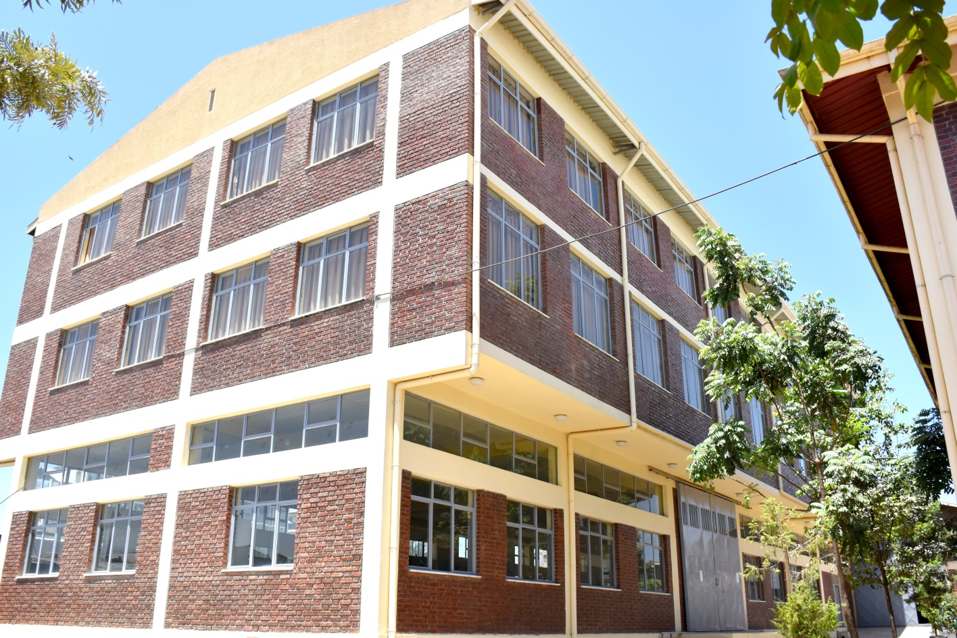

**APRIL, 2021**

**Introduction**

The Salesians of Don Bosco at Mekanissa have been looking to implement strategies that improve both the employability prospect of young men and women, and the sustainability of the TVET College. In order to secure a job and to find their way around the labor market, young women and men need not only the technical skills that enable them to attain decent work but also soft skills that equip them to perform effectively in contemporary workplaces and new markets.

A brief study and analysis basing ourselves on a need assessment survey that was conducted in and around Addis Ababa, and the study indicates that Accounting, Marketing Management, and Secretarial Science are the most market job demanded trades and soft skill trainings.

Based on the study findings, the college has been working on the process and the requirement needed to open the new soft skill department with the above mentioned trades. Accordingly, as per the Federal Technical Vocational and Educational Agency, and particularly as per the Addis Ababa TVET Bureau guidelines and requirements to obtain an official license for the new soft skill department the following mandatory steps were deemed necessary to fulfill and implement: Training needs and market demand assessment, curriculum and TTLM preparation, equipping classrooms with furniture and computers, classrooms and library minor repair and maintenance.

**Training needs and market demand assessment**

Training need and job market demand was conducted to determine if a training need exists and, if it does, what training is required to fill the gap. The study; assessment main objective was to seeks and identify accurately the levels of the present situation and near future demand in the job market.

In Addis Ababa there are many private colleges and institutions providing soft skill trainings, various kinds of trainings, training that have high demand and may be low demand in the job market from time to time. For us to identify, determine, set up and start the soft skill department and training, it was mandatory to conduct an assessment to exactly understand the market demand and cater our trainings accordingly. After all, our aim is for our trainees or young people to easily find a job and support them economically.

To do so we hired a consultant with an experience on this particular subject on the ground. The study area was Nifas Silk Lafto Subcity of Addis Ababa City Administration. The sample or total respondents were 210 were assessed. 100 preparatory school students, 60 government and private employees around Don Bosco Mekanissa, 10 government officials and private industry owners or managers, and 30 families of students in the sub-city participated in the study. The assessment came up with 97% of the respondents preferring Accounting Science, 90% Marketing Management, and 69% Human Resource Management, and 83% preferred Secretarial Science. Finally, the study recommended opening accounting department, marketing department, and secretarial science department. To do so the following requirements were found out to be necessary to execute.

**Curriculum and TTLM Preparation**

The reformed TVET-System is an outcome-based system. It utilizes the needs of the labor market and occupational requirements from the world of work as the benchmark and standard for TVET delivery. The requirements from the world of work in the three soft skill training fields were analyzed and documented –taking into account the Ethiopian TVET Qualification Framework.

As you may know, in the reformed TVET-System, curricula and curriculum development play an important role with regard to quality driven TVET-Delivery. Curricula and TTLM help to facilitate the learning process in a way, that trainees acquire the set of occupational competences (skills, knowledge and attitude) required at the working place and defined in the occupational standards.

For this specific task external consultant was hired, a consultant with this specific skills and experience on the ground. Based on the agreement and the TVET requirement, the expert prepared 79 Teaching Training and Learning Materials (TTLM), and 10 Curriculums of Accounting, Secretarial Science, and Marketing Management trainings. The document was submitted both in soft copy, and well organized/ hard copy and it is now readily available in the TVET College library.

During the preparation, the TVET management staff, and instructors were consulted and best experiences were adopted from other private and public training institutions.

The standard and quality of the curriculum and TTLM was also evaluated by the government TVET experts, and was well commended.

**Equipping Classrooms with Furniture and Computers**

The second requirement from Addis Ababa TVET Bureau is equipping classrooms, and simulation rooms with computers and furniture. As you know most accounting and computer science programs have been designed to provide students with instruction on financial performance, interpreting information, and recording and analyzing data. For this purpose, 21 Dell Desktop 500/4/19” flat screens with one year software warranty were purchased. These computers will help young boys and girls to learn how to use a variety of computer software programs, increase their typing speed, and mostly needed for the young students to get their hands-on experience in computer labs, office simulation, etc.

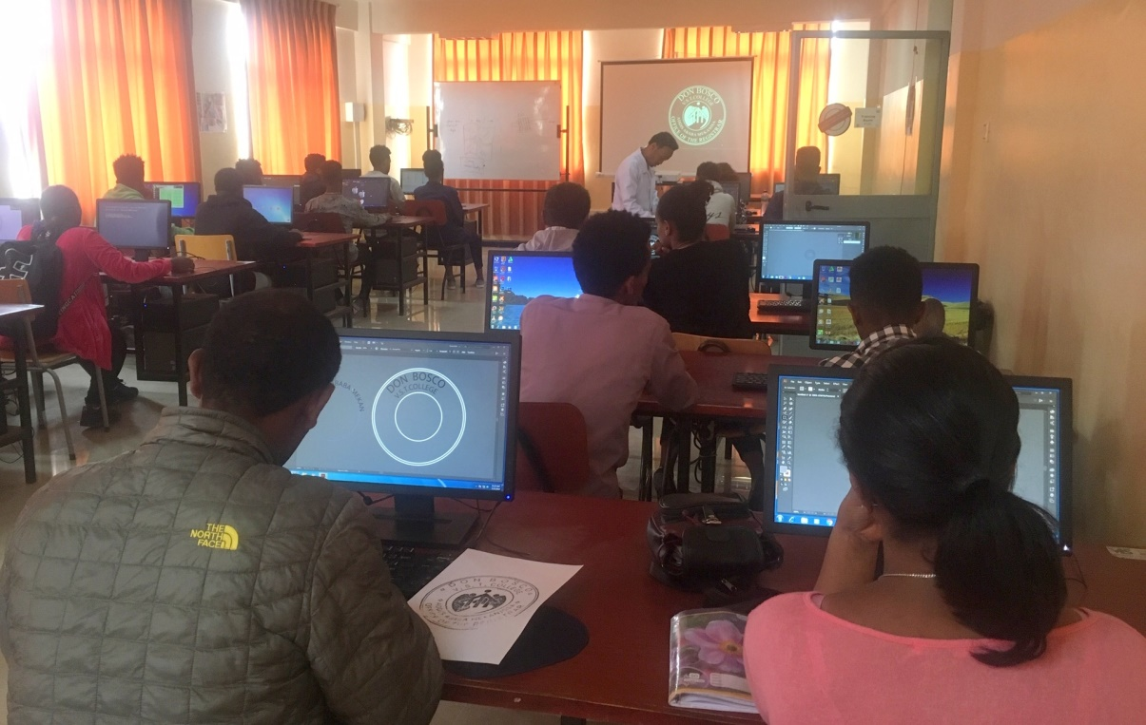

On the other hand, four classrooms were equipped with 120 arm chairs, each classroom with 30 arm chairs. The chairs were done externally by furniture making shop as per our requirement. Now the soft-skill department; the three trades classrooms are well equipped with furniture and are ready to use.

Besides, simulation rooms such for the soft-skills are fully and well equipped with furniture, table, computer, and chairs. It is a kind of simulation which resembles for example the bank transaction windows, and/or other service providing institutions reception desks/windows.

**Minor repair works in library and classrooms**

Maintenance, and minor repair works was done to renovate the classrooms and library to make it more functional and welcoming for the new soft skill trainees. Wall cracks, faded paints, computer network cable adjustments, etc. were some of the minor but necessary repairs.

In addition to these minor repair and maintenance, librarian circular table and chair were also made available to ease the work of the librarian and to ensure the standard and the general picture of the library.

**Financial expenditure**

|  |  |  |  |  |  |  |  |
| --- | --- | --- | --- | --- | --- | --- | --- |
| **Costs** | **Unit** | **# of units** | **Unit rate (in ETB)** | **Costs  (in ETB)** | | **Costs in Euro** | |
| Cost of computers | No. | 25 | 8000.00 | 200,000.00 | | 4,761.00 | |
| Cost of projector | No. | 1 | 25,000.00 | 25,000.00 | | 595.00 | |
| Cost of laser printer | No. | 1 | 5,500.00 | 5,500.00 | | 130.00 | |
| Cost of Writing Pad chair | No. | 70 | 1500.00 | 105,000.00 | | 2,500.00 | |
| Cost of Table for Computers | No. | 25 | 3500.00 | 87,500.00 | | 2,083.00 | |
| Cost of developing Curriculum | No. | 10 | 5000.00 | 50,000.00 | | 1,190.00 | |
| Cost of developing TTLM | No. | 184 | 1290.00 | 237,360.00 | | 5,651.00 | |
| **TOTAL** | | | | | **710,360.00** | | **16,913.00** | |